


FPT ACADEMY INTERNATIONAL

FPT – APTECH COMPUTER EDUCATION

RAINWATER HARVESTING

Center Name |  | FPT – Aptech – HCM2  Address: 590 Cach Mang Thang Tam, District 3, Ho Chi Minh City
Instructor |  | Ms. Le Mong Thuy
Class |  | T1.2109.M1
Group |  | 2
Group members |  | Name | Student ID
 |  | Nguyễn Phát Tài | Student1316806
 |  | Huỳnh Ngọc Thành  Nguyễn Phạm Thị Cẩm Tú | Student1339033  Student1335967
 |  | Nguyễn Hải Hoàng | Student1339262
Duration | Start date | 09th Dec 2021
Duration | End date | 10th Jan 2022

This is to certify that

Mr:

Nguyễn Phát Tài

Huỳnh Ngọc Thành

Nguyễn Hải Hoàng

Ms:

Nguyễn Phạm Thị Cẩm Tú

has successfully designed & developed

eProject: Rainwater Harvesting

Submitted by:

Nguyễn Phát Tài

Date of issue:
09th Dec 2021

Authorized Signature:


TABLE OF CONTENTS
FPT-APTECH COMPUTER EDUCATION 1
ACKNOWLEGMENT 3
SYNOSIS 3
PROBLEM DEFINITION 3
CUSTOMER’S REQUIREMENTS SPECIFICATION (CRS) 4
Business/project Objective 4
Hardware/software Requirements 5
SCOPE OF THE WORK (IN BRIEF) 6
Architecture and design of the system 7
Diagram of website 8
TASK SHEET REVIEW 1 9
SITE MAP 10
MOCK OF THE WESITE 11
1. Logo 11
2. Homepage 12
3. Rainwater Harvesting 13
a. Residential Area 13
b. Commercial Area 14
4. Methods 15
5. Developments 16
6. Contact Us 17
TASK SHEET REVIEW 2 18
WEBSITE DISCRIPTION 19
1. Homepage 20
2. Rainwater Harvesting
a. Residential Area
b. Commercial Area
3. Methods
4. Developments
5. Contact Us
JAVASCRIPT DISCRIPTION
Contact us javascript
TASK SHEET REVIEW 3

ACKNOWLEGMENT

On behalf of all the members of group 2, I would like to thank you all for the hard works, supports to make this eProject complete successfully. Especially, Ms. Le Mong Thuy, our teacher, she helped us a lot from the day that we started to study at FPT Aptech. With this eProject, she has guided us with her enthusiasm and rigorous, because of her guiding, we would be able to finish this project. Besides, I want to thank all the team member of group 2, each of the team member has been working continuously in 4 weeks in order to complete this project. The last but not least, we would like to say thank you to our family for always supporting us, creating the best conditions for us to focus on the project, and putting faith in the dreams we pursue.

SYNOSIS

In this task, we were assigned to design and develop a website that fulfills every request from a client called rainwater harvesting. The site is supposed to provide a user-friendly environment and navigation. The client's goals for the site were to reduce water bills, provide alternative supplies during water restrictions, and help maintain a healthy, green garden.

PROBLEM DEFINITION

We are here looking at a website which will provide brief details about few facts and details about rainwater harvesting. Rainwater harvesting (RWH) is the collection and storage of rain, rather than allowing it to run off. Due to the rapid growth of the internet, the company decided to set up a website where people could update information and understand more about rainwater harvesting more easily. You are supposed to create a website for them with the below mentioned requirement specifications.
The website is to be developed for the Windows Platform using HTML5, JavaScript and Geolocation. The site should work well in all leading browsers including Chrome, IE, Firefox etc.

CUSTOMER'S REQUIREMENTS SPECIFICATIONS (CRS)

Client: Aptech India

Business/Project Objective:

Rainwater harvesting (RWH) is the collection and storage of rain, rather than allowing it to run off. Due to the rapid growth of the internet, the company decided to set up a website where people could update information and understand more about rainwater harvesting more easily. You are supposed to create a website for them with the below mentioned requirement specifications.
The website is to be developed for the Windows Platform using HTML5, JavaScript and Geolocation. The site should work well in all leading browsers including Chrome, IE, Firefox etc.

Input to the system:

- Search for information about stormwater systems:Applications,Technologies, Advantages, Limitations, Country examples, History.

Output from the system:

- The home page about the description/images about various rainwater harvesting techniques should be provided. If user clicks on the same, navigational link must be available.
- There should be categories providing details about rainwater harvesting in various areas like residential area or commercial area, products available as well other techniques that can be applied.
- The site should also list and explain various facts related and methods that are applied for harvesting.
- Educate section: Inform people about using harvested water efficiently.
- Development section: Providing details about latest developments in the field of rainwater harvesting.
- Contact us page: contact us details with location should be displayed using GeoLocation API (eg. GoogleMaps).

Expected delivery date: 10th-Jan-2022

List of deliverables:

      - Document Word.
      - Source code.

Hardware/ Software Requirements:

- For developer
Hardware
  - Intel Pentium 4 processor or higher
  - 1 Gigabytes of RAM or higher
Software
  - Windows 7 OS or higher
  - Adobe Dreamweaver
  - Web browsers such as IE, Chrome or Firefox are supporting HTML5, CSS3 and Javascript.

- For web users
Hardware
  - Intel Pentium 4 processor or higher
  - 512 Megabytes of RAM or higher
Software
  - Windows XP OS or higher
  - Web browsers such as IE, Chrome or Firefox are supporting HTML5, CSS3 and Javascript.

SCOPE OF THE WORK (IN BRIEF)

After discussion, our group has decided to create a website contain the following webpages:

- Homepage: We divided the section into 3 parts:
- Part 1: Display our slogan.
- Part 2: Explain rainwater harvesting & its benefits to people.
- Part 3: Team info.

- Rainwater Harvesting: Explain harvesting in residential, commercial area and recommend suitable products for each area.

- Methods: Show people how to collect and use harvested water efficiently.

- Developments: Provide some latest developments in the field of rainwater harvesting.

- Contact Us: Contact details with location using GeoLocation API .

Architecture and design of the system





Webpage request
Requested Page
RENDERING
ENGINE
CSS CODE
HTML CODE
WEB SERVER
WEB BROWSER
CLIENT
SERVER

Diagram of the website

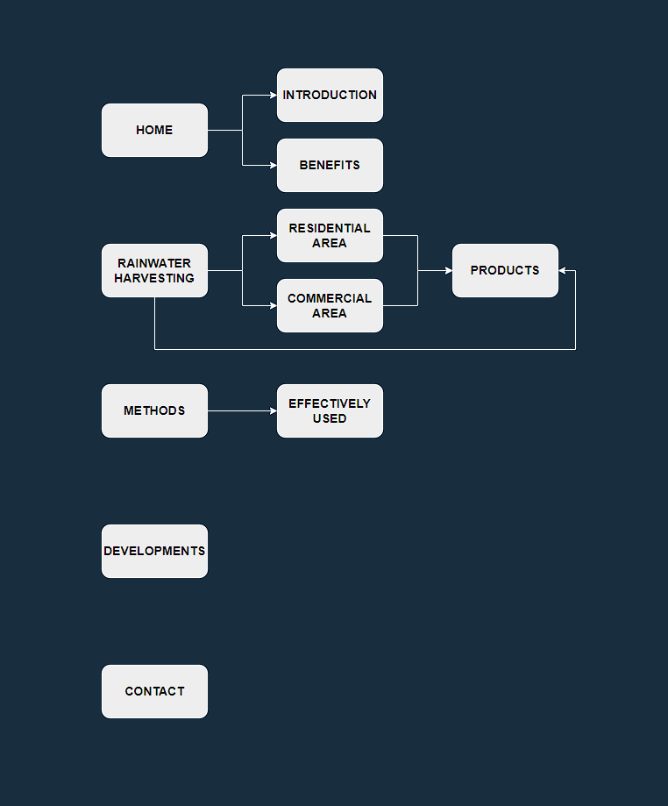






TASK SHEET REVIEW 1

Project Ref. No.:  eP/Advertisement Portal Management  System/01 |  | Project Title: | Activity Plan Prepared By: | Date of Preparation of Activity Plan:
Sr.  No. | Task | Project Title: | Activity Plan Prepared By: | Actual  Start Date | Actual Days | Team Mate Names | Status
1 | Problem Statement | Rainwater  Harvesting | Nguyễn Phát Tài | 09-Dec-21 | 1 | N.H.Hoàng | Completed
2 | Analysis of Rainwater Harvesting requirements about the website | Rainwater  Harvesting | Nguyễn Phát Tài | 09-Dec-21 | 1 | N.P.T.C.Tú | Completed
3 | The scope of the work (in brief) | Rainwater  Harvesting | Nguyễn Phát Tài | 09-Dec-21 | 1 | N.P.Tài | Completed
4 | Architecture and design of the system | Rainwater  Harvesting | Nguyễn Phát Tài | 09-Dec-21 | 1 | N.P.Tài | Completed
5 | Diagram of the website | Rainwater  Harvesting | Nguyễn Phát Tài | 09-Dec-21 | 1 | H.N.Thành | Completed
6 | Task Sheet | Rainwater  Harvesting | Nguyễn Phát Tài | 09-Dec-21 | 1 | N.P.Tài | Completed

Date: 09th Dec 2021
Signature of Instructor:  Ms. Le Mong Thuy | Signature of Team Leader:  Nguyen Phat Tai

SITE MAP

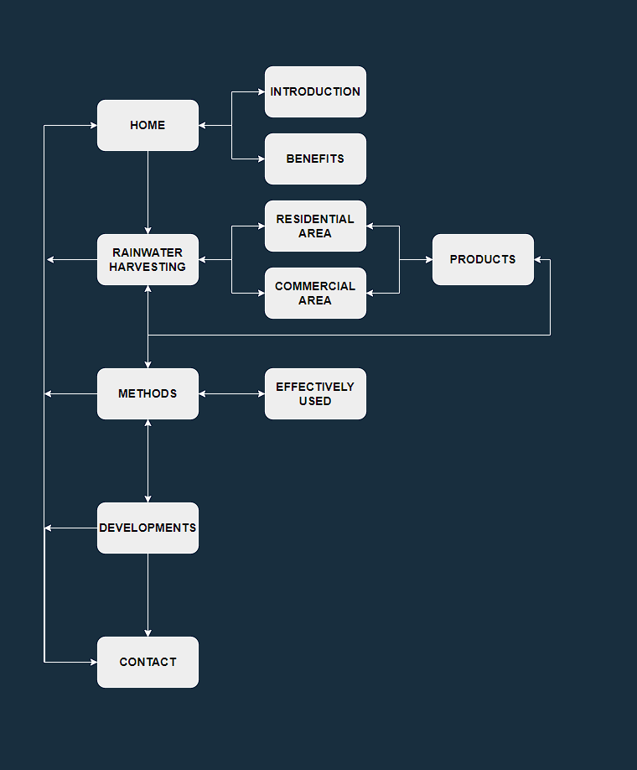

MOCK OF THE WEBSITE

- Logo

This logo is designed by Huỳnh Ngọc Thành - Student1339033



- Homepage
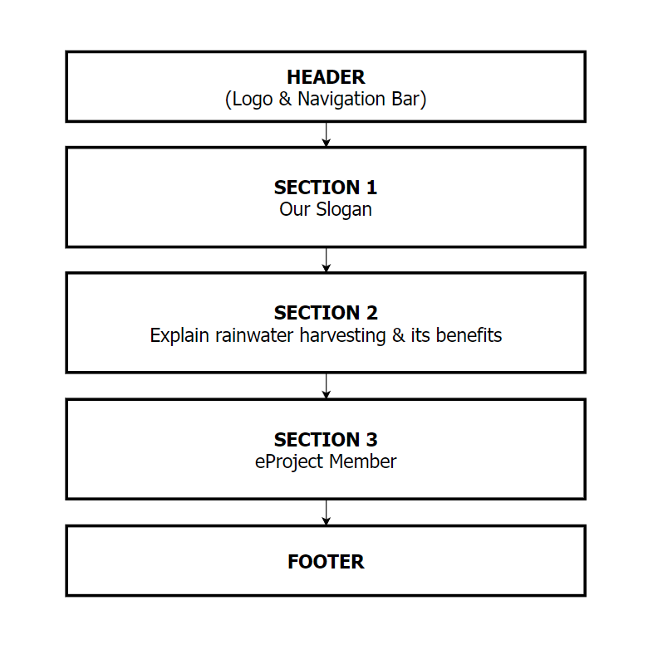

- Rainwater Harvesting

a. Residential Area

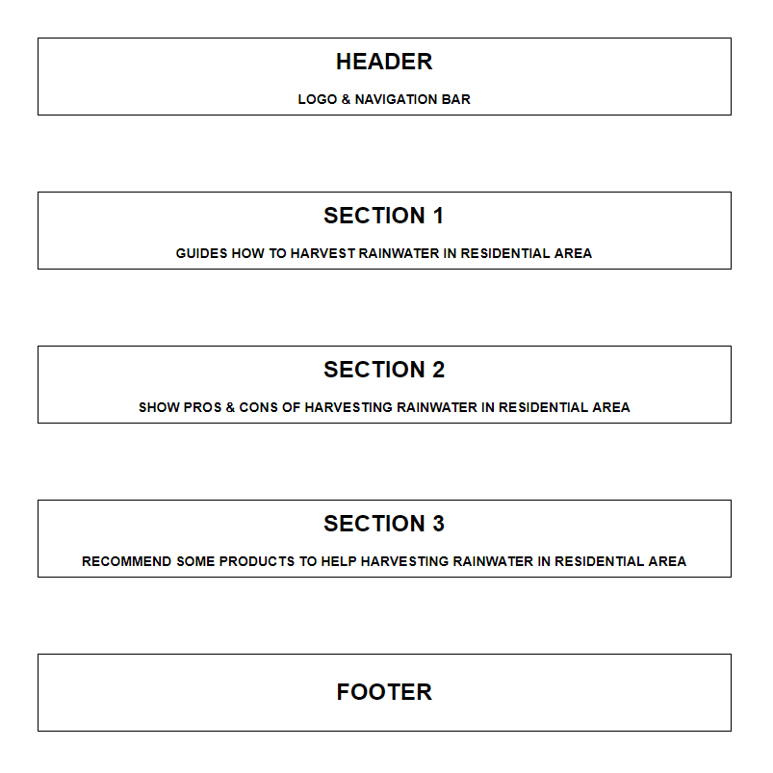

b. Commercial Area 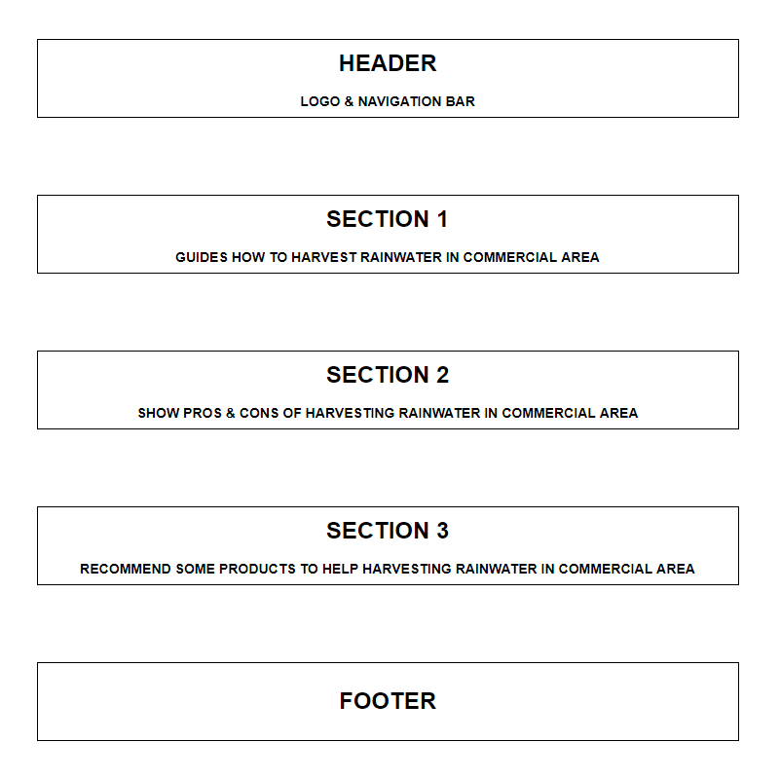

- Methods

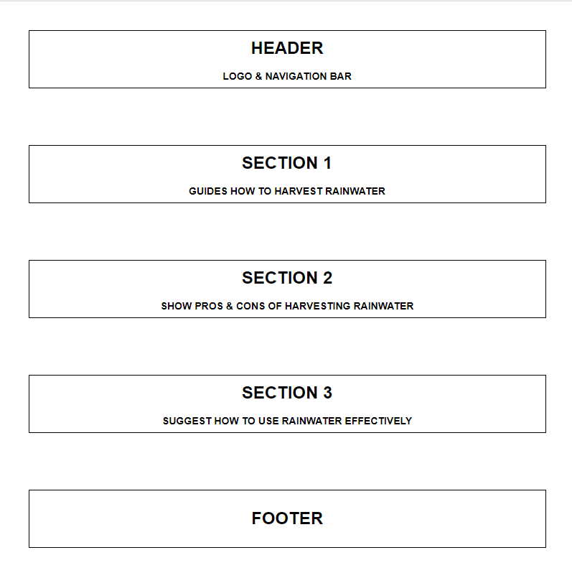

- Developments
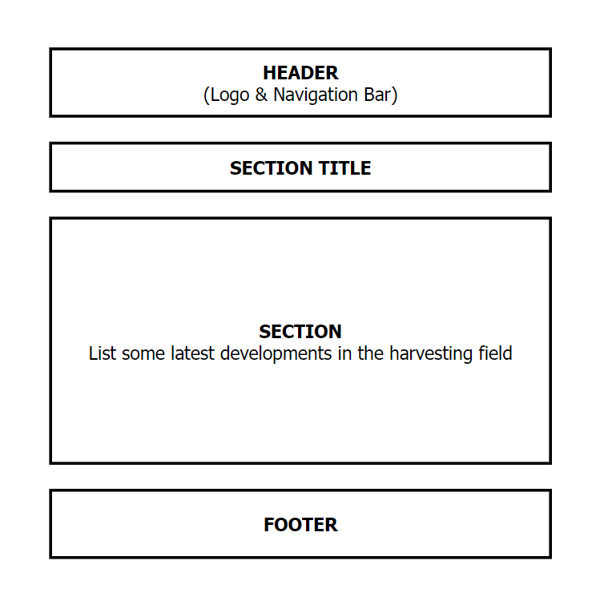

- Contact Us
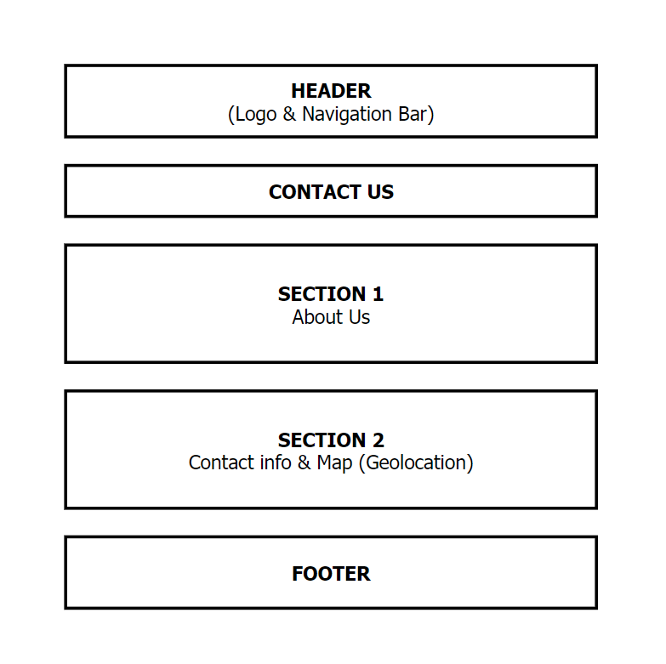

TASK SHEET REVIEW 2

Project Ref. No.:  eP/Advertisement  Portal Management System/01 |  | Project Title: | Activity Plan Prepared By: | Date of Preparation of Activity Plan:
Sr.  No. | Task | Project Title: | Activity Plan Prepared By: | Actual Start Date | Actual Days | Team Mate Names | Status
1 | Site map | Rainwater Harvesting | Nguyễn Phát Tài | 10th-Dec-2021 | 1 | H.N.Thành | Completed
2 | Mock of the website | Rainwater Harvesting | Nguyễn Phát Tài | 10th-Dec-2021 | 1 | H.N.Thành  N.P.Tài  N.P.T.C.Tú  N.H.Hoàng | Completed
3 | Task sheet | Rainwater Harvesting | Nguyễn Phát Tài | 10th-Dec-2021 | 1 | N.P.Tài | Completed

Date: 10th Dec 2021
Signature of Instructor:  Ms. Le Mong Thuy | Signature of Team Leader:  Nguyen Phat Tai

